DATE: | VERSION: | PRODUCT NUMBER: | PRODUCT NAME:
3/11/2023 | 1 | 1-858 | Choc Salted Caramel Tart

PRODUCT DESCRIPTION
This decadent dessert features a delicate, crunchy chocolate tart shell, filled with luscious, salted caramel, layered with smooth dark chocolate ganache and topped with crispy chocolate coated wafer pearls.

PRODUCT INGREDIENT DECLARATION
Ingredients: Wheat Flour, Vitamins (Thiamin, Folate), Butter (Cream (Milk), Water), Sugar, Caramel Filling (11%) (Sugar, Sweetened Condensed Milk, Butter (Milk), Dextrose, Vegetable Fat (Emulsifiers (322, 492)), Glucose (Preservative (220)), Inverted Sugar, Thickener (1422), Emulsifier (471), Caramelised Sugar, Salt, Natural Flavour, Preservative (202)), Tapioca Starch, Egg, Potato Starch, Dark Compound Chocolate (3.5%) (Contains Milk, Emulsifier (492, 476, 322 (Soy))), Cocoa Powder, Margarine (Contains Milk, Emulsifiers (471, 322 (Soy)), Food Acid (330), Natural Colour (160a), Vitamins A & D), Thickened Cream (Milk), Vanilla Essence, Chocolate Extract, Salt (Contains Anticaking Agent (554)), Thickener (415 (Soy)), Dark Chocolate Pearls (Contains Milk Fat, Soy Lecithin, Wheat Flour, Raising Agent (500ii), Glazing Agent (414)), Milk Chocolate Pearls (Contains Milk Powder, Soy Lecithin, Wheat Flour, Raising Agent (500ii), Glazing Agent (414)), White Chocolate Pearls (Contains Milk Powder, Soy Lecithin, Wheat Flour, Raising Agent (500ii), Glazing Agent (414)), Vegetable Fat (Contains Emulsifier (492, 322 (Soy)), Food Acid (330)), Stabiliser (471).

ALLERGEN DECLARATION
Contains: Gluten, Wheat, Egg, Milk, Soy.
May contain Peanut, Almond, Hazelnut, Macadamia, Pecan, Pistachio, Walnut, Lupin.
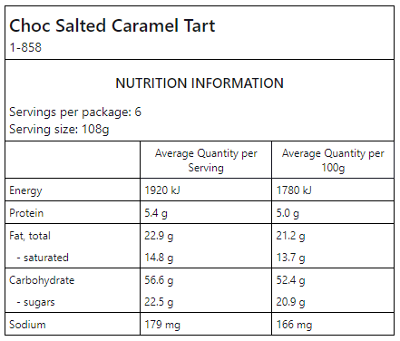

PRODUCT SPECIFICATIONS
Final Product Weight | 648g
No. of Units per Inner | 6
No. of Units per Outer | 6
Pallet Dimensions | Ctns per Layer: 8 | No. of Layers: 5 |  | Ctns/pallet: 40
Barcodes  (Including check digit) | EAN 933104302382(6) | TUN 1933104302382(3)
Shelf life | Primary: 364 days | Secondary: 5 days chilled, 3 days ambient
Inner Dimensions (m) | Height: 63mm | Length: 303mm | Width: 213mm
Outer Dimensions (m) | Height: 202mm | Length: 441mm | Width: 336mm
Inner Packaging | Corrugated Fibre Board
Outer Packaging | Corrugated Fibre Board
Country of Origin | 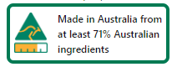
Methods of Preservation | Frozen
Halal Status | Pending

MICROBIAL SPECIFICATIONS
Parameter | Specification
Standard Plate Count | <1x10⁴ cfu/g
Yeast and Mould | <1x10³ cfu/g
Coliforms | <100 cfu/g
E. coli | <3 cfu/g
Listeria monocytogenes | ND in 25g
Salmonella | ND in 25g

LABEL SAMPLES
INNER LABEL SAMPLE
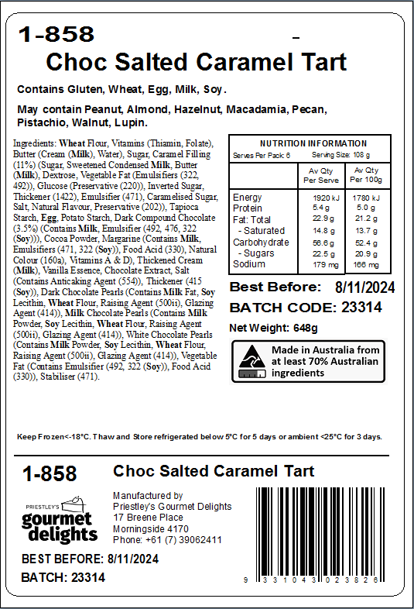

OUTER LABEL SAMPLE
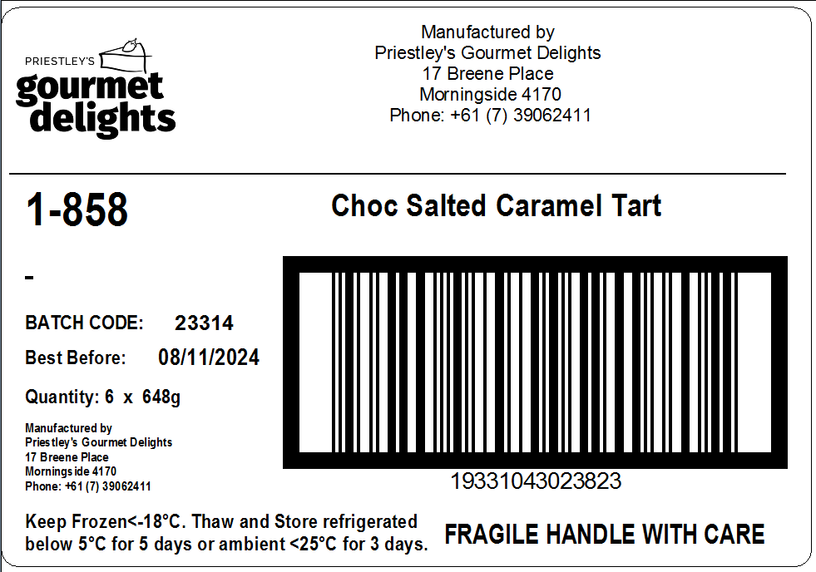

PRODUCT IMAGE:
